**Aim:**

**Program:**

**Output:**

4.WWP to enter any number and check whether the number is palindrome or not.

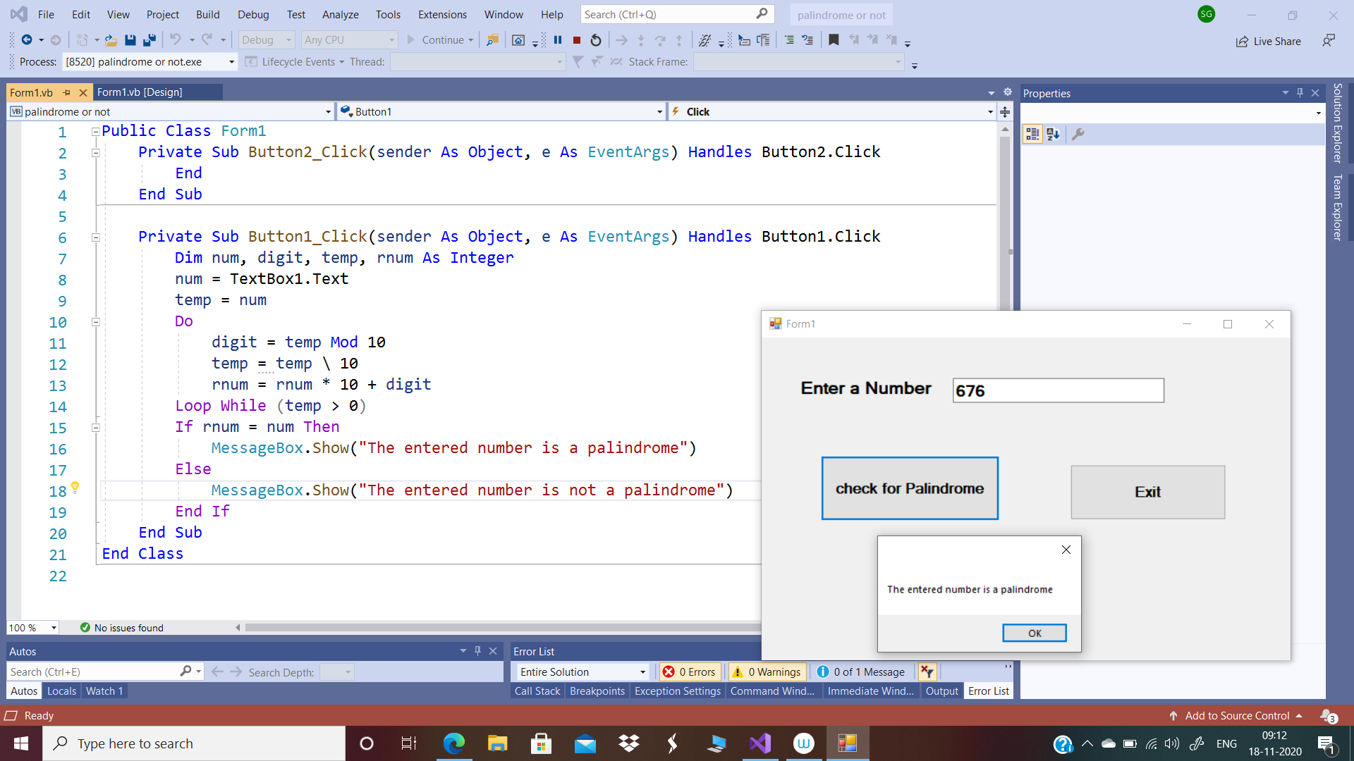

5. WWP to enter any number and check whether the number is perfect or not.

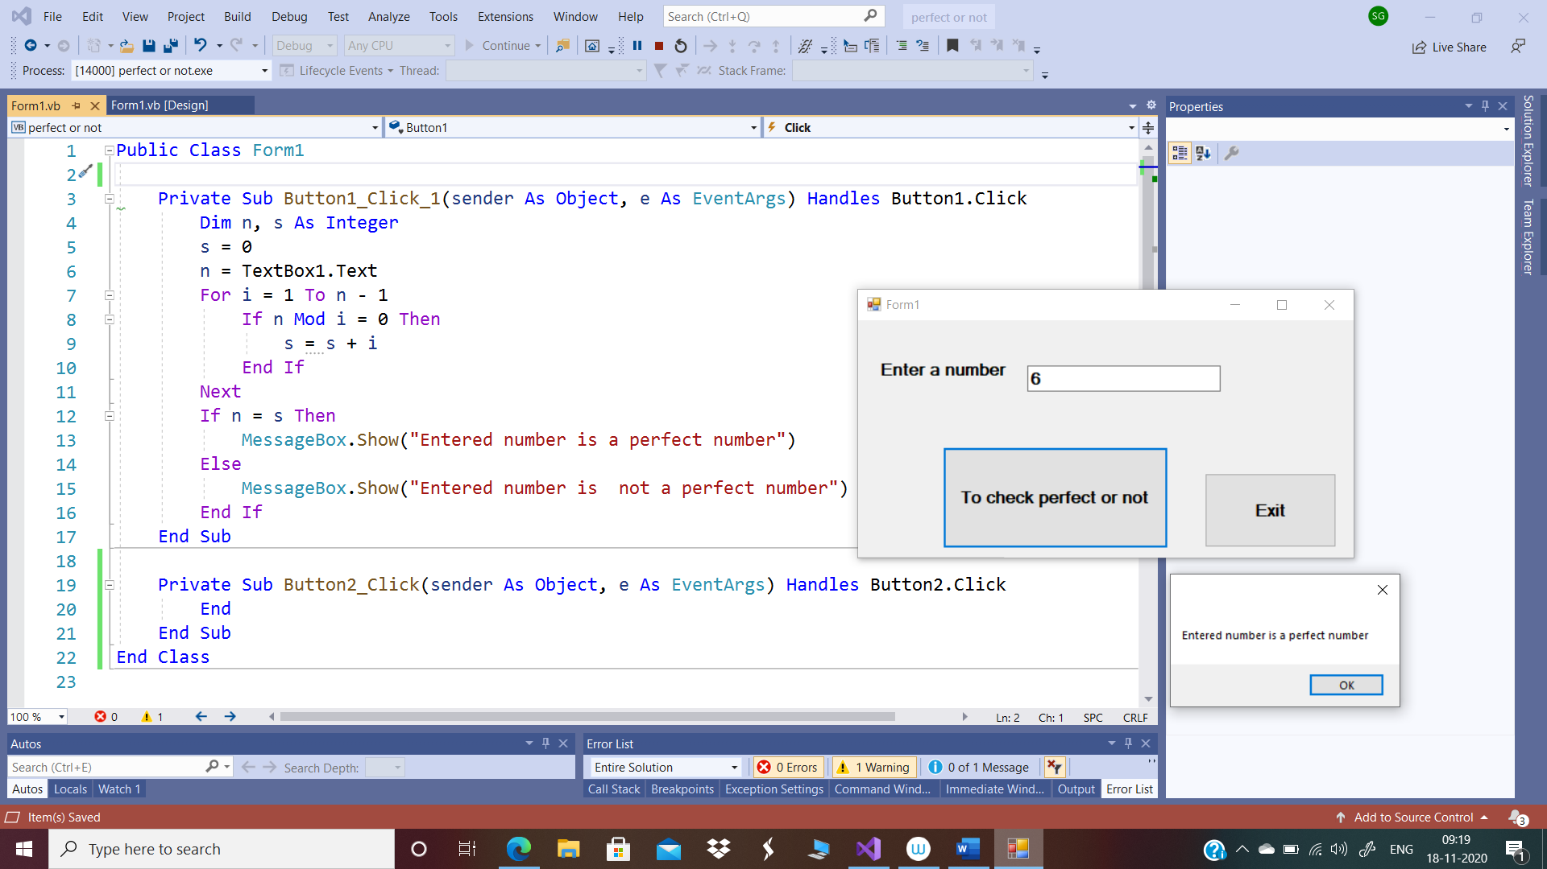

6. WWP to enter any number and check whether the number is prime or not.

